Tanner Wale

## **Tech Trends of 2025: The Future of Innovation, Emerging Technologies, and Career Opportunities**

Top 10 tech trends in the IT industry. The Tech industry trends are always changing for the future of innovation, emerging technologies, and career opportunities. This article will talk about new changes in industries caused by technology advancements. If you enjoy learning new ways technology is changing our lives, this article is for you.

## **Quantum Computing**

Quantum computing is a tech trend that keeps coming up in the tech industry. This is due to its help in security with cryptographic functions by making Post-Quantic Cryptography or PQC. This can withstand traditional and quantum computing attacks providing security into the future (Fortinet, 2025). This gives a high advantage to future security and makes it that much harder for attackers to infiltrate.

Quantum computing also provides new features in security with Quantum Key Distribution, that allows detection of eavesdropping attempts. Alerting the two authenticated people in a session. It does this if someone else tries to intercept the key, for a party between two authenticated people.

There are new enhanced security protocols that are more efficient at detecting an intrusion and identifying vulnerabilities. The process and analysis of data are much faster and improved through quantum computing. This is because quantum computing processes data much faster than traditional computing. This in turn leads to faster detection of vulnerabilities. Strengthening the defenses of the organization overall.

Another notable addition that quantum computing makes is the faster development of life-changing drug treatments. Potentially providing solutions to fighting Alzheimer's and cancer (SpinQ, 2025). This enhanced technology is able to simulate molecular interactions according to (SpinQ, 2025), which enriches researchers in new designs, prediction of molecular behavior, and better treatment plans for patients (SpinQ, 2025).

Quantum computing will also help with AI by making faster analysis of data sets. Quantum computing has faster processing power than traditional computing power. According to (Tran, 2025) this can be attributed to 10 to 1000 times faster for AI training models. While also lowering the energy consumption needed for processing the data sets in record time (IBM, 2025).



Photo by Christina Morillo: <https://www.pexels.com/photo/two-people-working-on-laptops-1181210/>

Two people working on blue laptops

## **Career Opportunities in Quantum Computing**

Quantum computing is far superior to anything else right now, because of its capabilities to extend other technologies. To do so you will need engineers in many different fields. Also, more research done to find all quantum computing has to offer.

* Quantum Hardware Engineer
* Quantum Software Engineer
* Quantum Research Scientists
* Quantum Data Analysis
* Quantum Network Engineer

## **Generative AI**

Generative AI is a very hot topic in the tech industry at the moment, due to its help in creating content on the internet through the automation of large data sets. These data sets or data, are from posted writing on the internet. What Generative AI can do is compile all of this (data) to produce different writing samples.

Generative AI can take the content of a sports writer talking about a National Basketball Association or NBA game. Repurpose that writing style (National Basketball Association or NBA writing style), for a technical document, something like, “How to protect your computer.”

Now, Generative AI will write a technical document about “how to protect your computer.” Using an NBA sports writer's voice from samples taken of NBA sports writer articles.

In order for the technical document to have useful information about “how to protect your computer.” You could add data or samples from trusted sources with technical documentation about “how to protect your computer.” Generative AI can then be used to talk in-depth about the subject of “how to protect your computer”.

This gives the technical document an in-depth analysis of the subject by using the technical documentation samples. While still using the NBA sports writer’s samples to talk in a sports writer’s voice about “how to protect your computer.”

Generative AI can be used for writing as we mentioned. This is only one of the many uses of Generative AI. You can also use it for creating content for images, videos, and even audio. This is done through the same lens as writing a technical document using Generative AI. With the writing style of an NBA sports writer.

Generative AI can be used for cancer treatment plans and show you the expected outcome, based on the patient’s data. Through the development of drugs in the healthcare industry. Generative AI can be precise in simulating how drugs will interact with molecular structures. Lowering the cost of development in drugs by reducing the time it takes to develop them. There are many more ways Generative AI is being used such as in the IT industry.

Generative AI can be used in the tech industry for simulations of new emerging threats. It can also be used for incident response procedures. Employees of organizations need to practice procedures to have a timely response to new threats. This is due to the large amount of sheer volume that Generative AI can scan through. To find these new attacks and create new simulations of them.

While also having a playbook response in cybersecurity. On how to respond to the threat in the simulation. AI can guide you step by step until the threat is resolved and time you. It can then record that response procedure and see any mistakes made. It can then compare your time to the organization’s requirements of response time to a threat.

It is much better to have Generative AI doing these tasks than a human. The accuracy, predictions, and learning curve of AI protect organizations better against attacks than humans. From a standpoint of new emerging threats and predicting where the attack will take place. Generative AI benefits organizations much more than humans doing these tasks.

This is because this is a repetitive task in the cybersecurity community. There will always be new emerging threats and ways to go about predicting them successfully. Human error in repetitive tasks will always be a vulnerability. Now with the help of Generative AI, we can make this area of vulnerability turn into a strength against attacks. While we use humans to fix more complex issues in cybersecurity.



Photo by Solen Feyissa: <https://www.pexels.com/photo/close-up-of-a-person-holding-a-smartphone-displaying-chatgpt-20870795/>

A person Holding a Smartphone Displaying ChatGPT

## **Career Opportunities in Generative AI**

Generative AI will need engineers to build more complex models and extend the capabilities of Generative AI. With any AI system testing will need to be done. Also, the protection of Generative AI’s data sets so that data poisoning attacks don’t have success.

* AI Data Architect
* AI Network Engineer
* AI Data Analyst
* Research Scientists
* Data Scientists

## **5G Networks**

5G is becoming the norm in public networks. As it gives faster speeds to download and upload documents, videos, and audio. 5G has speeds between 1Gbps - 3Gbps compared to 4G’s 20Mbps - 100Mbps (Goss, 2023).

At 4G’s fastest speed of 100Mbps, it is still 10 times slower than 5G’s lowest speed of 1Gbps. This will overall improve people's performance on the internet by faster downloading and uploading of content.

Another key performance in using 5G is the lower latency. As pointed out by (Goss, 2023), 4G networks will have between a 60-98 millisecond latency. While 5G will have less than 2 millisecond latency. This leaves instantaneous response time for people using 5G to complete their work faster. Rather than having to wait for network responses, that can leave people feeling a slight delay after every click.

One advancement that 4G did not have that 5G does is a wider capacity of users and devices. What makes 5G awesome is the new technology it uses that 4G doesn't have. 5G’s new millimeter waves or mmWave frequency bands (Goss, 2023) are for smaller areas, but provide much faster speeds than normal (1Gbps- 3Gbps) 5G capabilities.

This is part of the reason for 5G network installation over 4G networks. As placing down small stations that can transmit mmWaves, so that 5G can be used by more businesses and users in rural areas. Areas that 4G networks could not reach to support user’s devices before. During my time as a Help Desk Technician, people were calling with trouble to their devices for the first time. This is because 5G was able to reach areas that 4G networks were not capable of doing.

Overall, the performance of 5G compared to the previous version 4G will leave better performance reviews in every category. This is why 5G networks are being implemented over 4G networks.

You can see in real-time with 5G networks which is very important for businesses. 5G makes remote work more common today than ever. This is because 5G offers lower latency, faster download and upload speeds, and supports more devices and users.

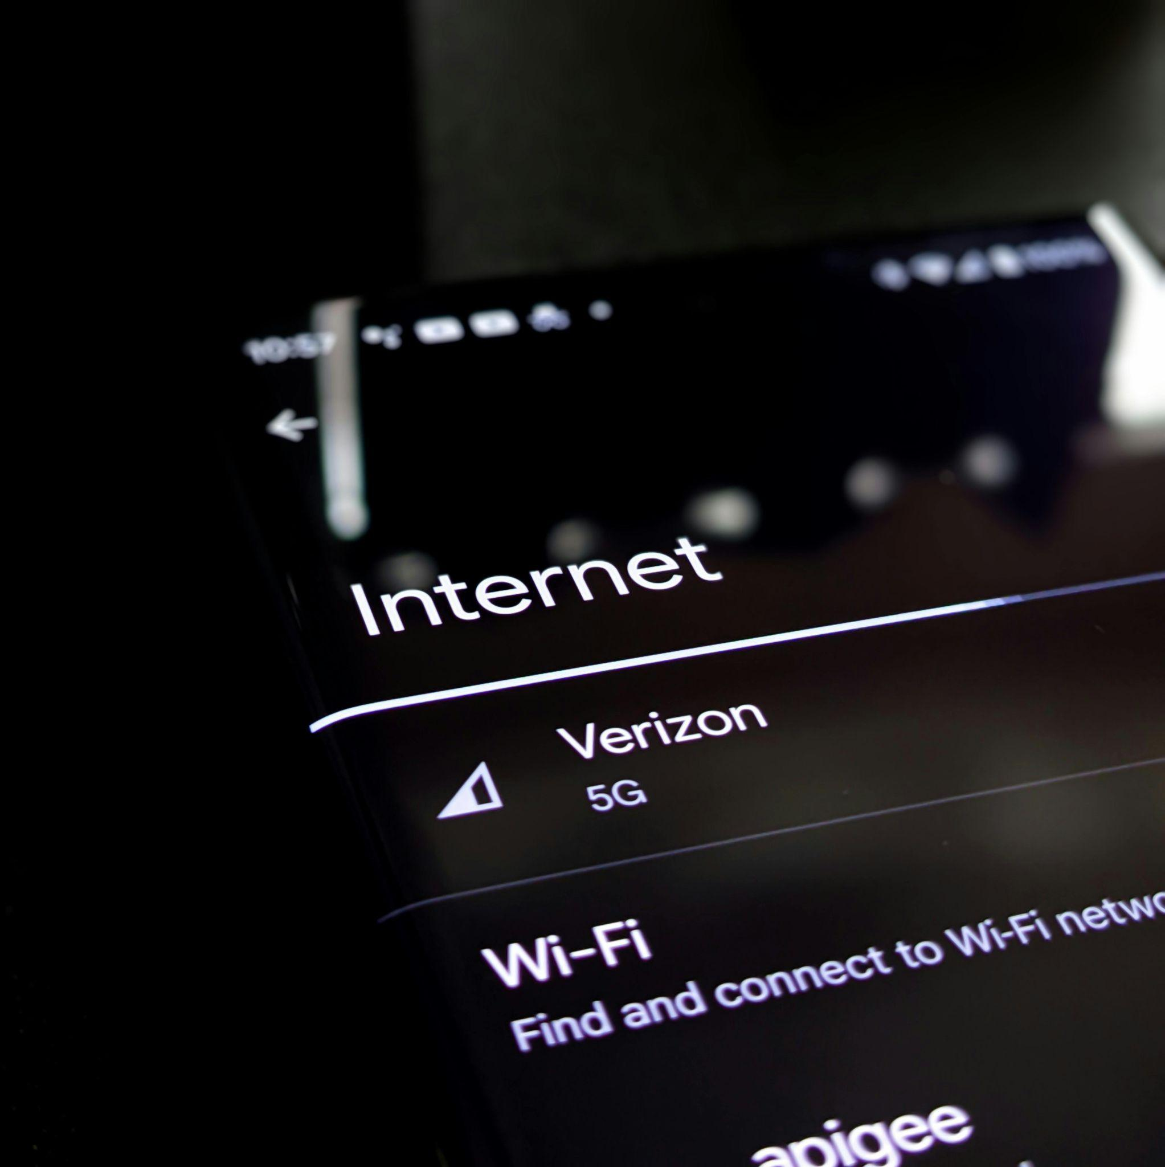

Photo by Obi Onyeador: <https://www.pexels.com/photo/close-up-of-a-phone-screen-13029652/>

Connection to 5G network on phone

## **Career Opportunities in 5G Networks**

5G networks have been planned out by an architect to design where towers need to be placed. This gives the best coverage for customers, so it is a vital part of 5G. Next, 5G networks need someone to understand the different frequencies of a network, especially the new millimeter wave (mmWave).

* Network Architect (DADB, 2024)
* Field Technicians
* Network Engineer
* Radio Frequency Engineer (Tonex, 2020)
* Cloud Engineer

## **Internet of Things (IoT)**

Internet of Things or IoT, is a beneficiary of 5G network installation. Connecting networking devices that share data between one another. You can access your security cameras when you leave your house on your laptop or phone.

You can change the thermostat of your house on your laptop or phone. You can also use Alexa to change the temperature on your thermostat. These options only scratch the surface. Many IoT devices have ways of changing settings but the phone or laptop are easier methods of doing so.

One of the many ways IoT is being used is for monitoring other devices. Organizations need servers in order for customers to access their important data.

IoT can monitor the health of servers to respond faster to incidents. IoT can spot inconsistencies in the data it collects on a server, to know when it will turn off. Helping pave the way for less downtime and more uptime. Providing another way for businesses to save their money from unexpected server downtime.

IoT is used for monitoring the vital signs of people as well. The data IoT collects can be sent to a hospital in real time to closely monitor your vitals. IoT can predict from the data it collects if there is any risk to one’s health. This can provide a deeper analysis of a patient’s health and certain areas that need improvement. IoT can also take this analysis and display treatment options for the patient.



Photo by Kindel Media: <https://www.pexels.com/photo/person-using-mobile-phone-8566440/>

A person using their phone to connect to IoT Rumba

## **Career Opportunities in IoT**

IoT focuses on monitoring and data. Finding the best ways to collect data and draw conclusions. To improve the organization's procedures and policies. Also, because there are so many different uses of IoT. The need for someone to understand a wide range of different formatted data is a must. Another notable acquisition is security for IoT. As IoT lacks in many parts of security, and there have been very many reports of data alerting.

* Data Analysis
* Full Stack Developer
* Cloud Engineer
* IoT Security Engineer (Indeed, 2024)
* Data Scientists

## **Edge Computing**

Edge computing is beneficial to all organizations. Also, edge computing has gained more traction thanks to the high processing download and upload speeds of 5G networks. This shifts focus from the cloud processing all the data at once. Which leads to more latency, higher bandwidth demands, and slower analysis of data.

With edge computing, you set up smaller networks that are for processing and analyzing data. Utilizing the cloud for more advanced or important analysis of data. This provides an organization with faster data analysis, less bandwidth usage, and lower latency issues.

By getting real-time analysis of data back quickly, the organization can make changes to improve efficiency. This can help industrial factories with cost-effectiveness. If a machine keeps having repairs done to it to operate at full capacity. It could be a sign to look at other options. Edge computing analysis could find on certain days it is better to run than others. Letting the business gain from more of their resources.

Thanks to using edge computing, you do not have to wait on the cloud to perform this cost analysis. Also, if you want a second opinion on the cost analysis. You can send that data to the cloud. Edge computing helps as unimportant data is disposed of to perform this analysis faster. While also providing your network with less network congestion, because you only send data you need an analysis of.

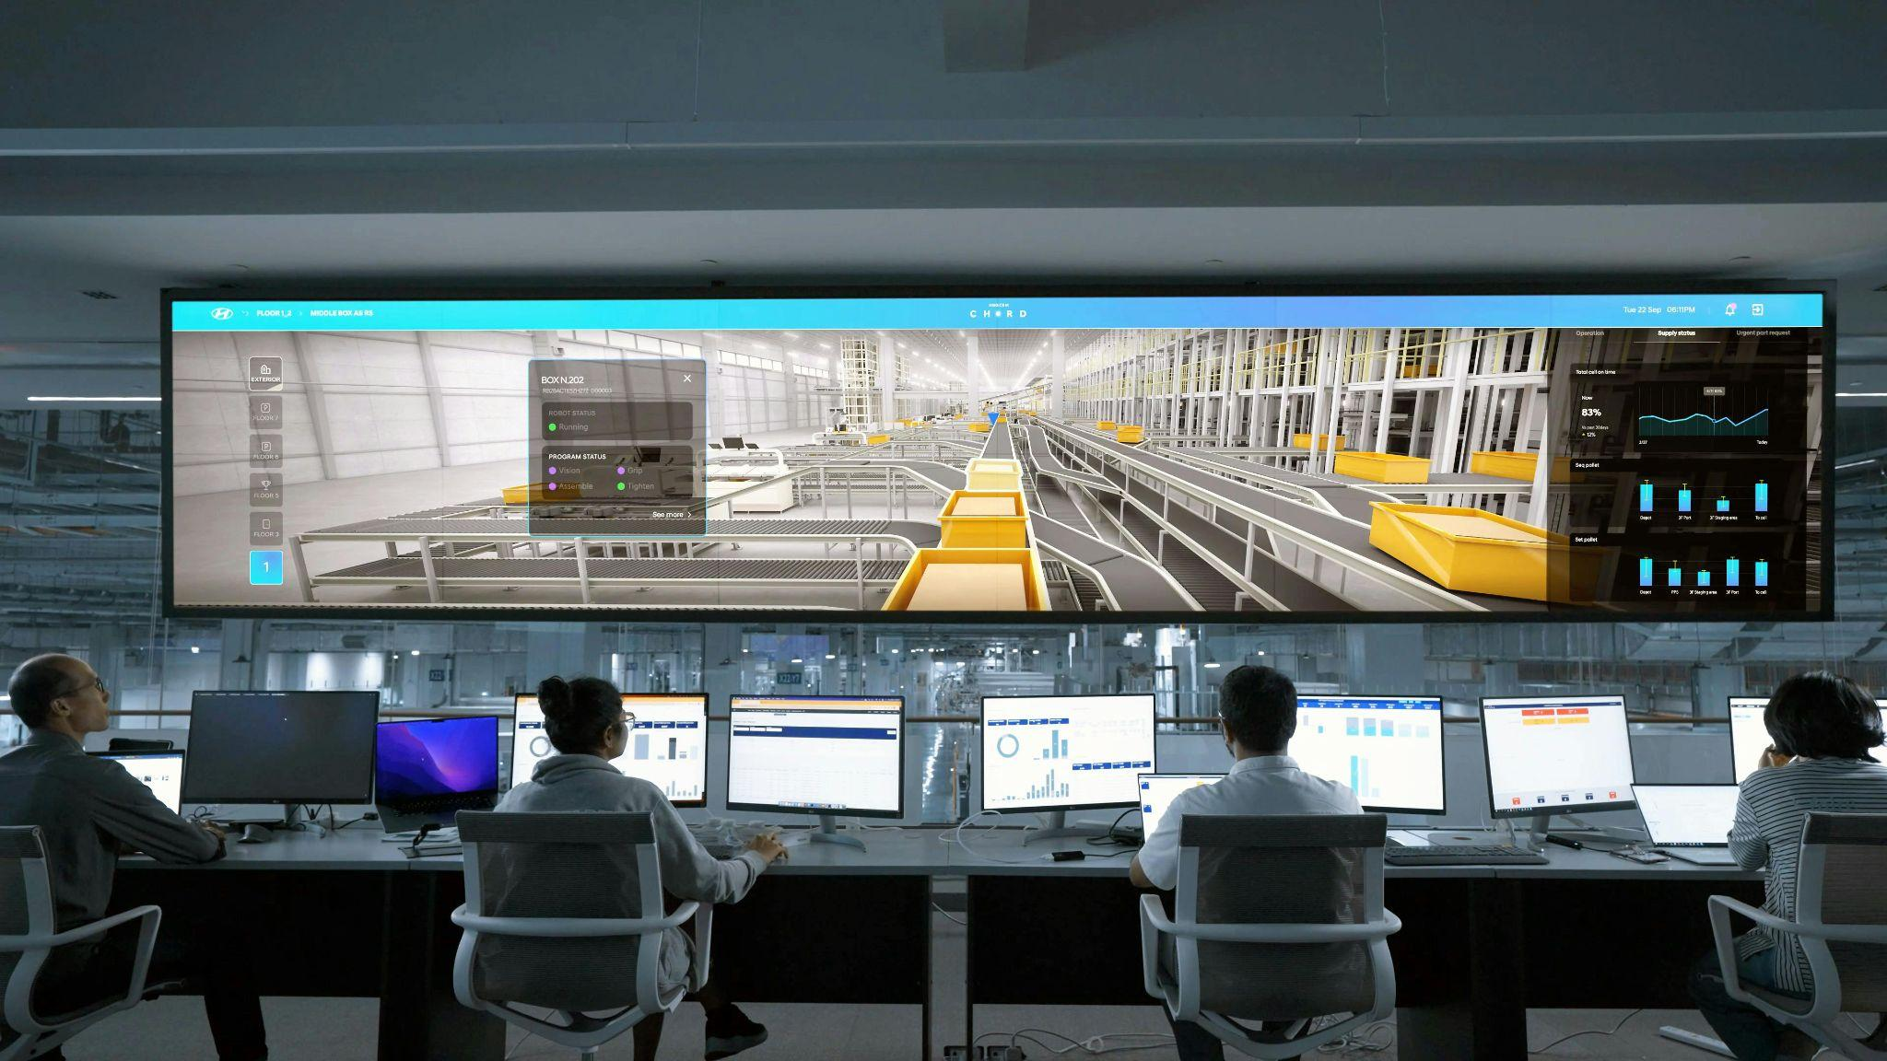

Photo by Hyundai Motor Group : <https://www.pexels.com/photo/men-and-women-sitting-in-front-of-computers-and-a-large-screen-19317897/>

Men and women sitting in front of computer and a large screen of data

## **Career Opportunities in Edge Computing**

Edge computing focuses on data and efficient ways to process that data in real time. Also, it points focus to systems in the network and the most efficient ways to utilize them. To gain maximum benefit from their systems.

* Data Analyst
* Network Engineer
* Data Scientists
* Network Architect
* Network Systems Administrator

## **AI in Cybersecurity**

The benefit of AI in cybersecurity is that humans could spend their time being more efficient. In the past humans have done repetitive tasks in cybersecurity.

It could be vulnerability scanning or looking through logging systems in order to find potential threats. With the help of AI, humans can focus on more important tasks. Involving response to high security risks, to help make a better defense against threats.

AI is also better at the accuracy of threats than humans. For accurately finding threats in log analysis and vulnerability scanning at a much higher rate than humans. This is because of human error. When humans do repetitive tasks they get burnt out, lose patience, or simply quit caring. Removing this human factor with AI makes for a better detection of real threats.

This is most of the grunt work in cybersecurity as every user leaves a digital trail on the internet. AI can get through all of these digital trials faster than humans and report threats in real-time.

Another benefit of using AI in cybersecurity is it can automate decision-making for security. This helps organizations with defending best against common and even uncommon attacks. AI can automate adding procedures to the organization that will lead to better results, in preventing attacks.

To recap AI in cybersecurity and its impact. AI is cost-effective in security. Its use leads to better results than cybersecurity professionals. It reads through logging systems faster and performs vulnerability scans faster than humans. AI gives real-time analysis of threats due to its speed in detection. Also, AI gives better accuracy in security, with fewer false positives.

Finally, it benefits an organization because their employees no longer have to do these repetitive tasks. Leading to higher efficiency than ever in security. AI can scan a database for security measures. Meaning it checks for the security posture, aligning it with policies and procedures to be safe from attacks. By humans focusing more on robust security with high risks, fewer disasters in security will be compromised.



Photo by cottonbro studio: <https://www.pexels.com/photo/a-woman-in-a-tank-top-using-a-vr-headset-8721322/>

A person sitting on the floor using VR goggles and a computer

## **Career Opportunities in AI in Cybersecurity**

First of all, understanding AI in cybersecurity is the main focus. Then, understand ways to leverage AI’s capabilities for security. Monitoring AI and testing are next without these you leave holes in security. Finally, someone who can give instructions to AI to detect and find ways to mitigate attacks.

* AI Tester
* AI Data Scientists
* AI Data Engineer
* AI security Architect
* AI Programmer

## **Blockchain**

Blockchain has great promise for the now, and into the future. It helps with the integrity of information. By installing computers across a network. With shared records of information. That can log changes made across the network of information. The blocks in a blockchain are the records of information that have all shown signs of integrity.

Forming a blockchain of information over time, of records of valid information. These “blocks” all have cryptographic hashes, meaning if one is altered by an unauthorized change. It detects and shows signs of data manipulation. This form of data integrity prevents attacks from altering data that could harmfully impact an organization.

The blockchain of information is better than the traditional storing of information. This helps detect signs of changes to important information. To give an example, think of your banking records. The traditional way of recording changes to banking records was using a centralized server.

This is a security risk because all information is stored in this one location on a network. Attackers knew this and would attempt to infiltrate it for the information. This is a security risk due to the single point of failure.

If an attack is successful you will lose records upon records of banking information. Also, you would have to shut down your network, losing more money from a breach. Another aspect is that more than one patient’s information could be stolen from this one attack.

By using blockchain you keep information across multiple devices and use cryptographic hashes of each record. This makes it harder for attackers to infiltrate.

This is because an attacker would have to gain access to a majority of the systems (Level Blue, 2024). In order to influence the acceptance of altering data or invalid banking records. The attacker would need to spend an enormous amount of time and resources to break the blockchain.

Reducing the number of successful attacks on an organization. Also, the attacker would be spotted from a mile away with an attack. If one “block” showed signs of an attack that system could be taken offline to prevent further damage. Helping make it easier for cybersecurity professionals to defend their networks and systems.



Photo by Polina Zimmerman: <https://www.pexels.com/photo/photo-of-computers-near-window-3747486/>

Multiple computers side by side

## **Career Opportunities in Blockchain**

Blockchain is becoming more common. To help with the installation and maintenance of this architecture. An overall understanding of architecture will be needed. As well as data management of multiple systems. Complex data analysis of data that could be in a different format, than another system holding the same information.

* Blockchain Data Analyst
* Blockchain Data Scientist
* Blockchain Data Engineer
* Blockchain Architect
* Blockchain Software Engineer

## **Sustainable Technology**

Sustainable technology is building technology to find solutions to environmental problems. Examples of sustainable technology are smart thermostats and water-saving fixtures. Here are a few more in-depth views of ways sustainable technology has and will continue to help humans.

LED lights are sustainable technology. This is because the swap from fluorescent bulbs to LED lights makes it safer to use light bulbs. This is a huge part of society too. From lighting roads in inner cities to decorating houses, for a holiday, with a thousand LED lights.

The safety stems from some older fluorescent bulbs using mercury (Beyond, 2024). Which is a highly toxic chemical that can kill humans. Older model bulbs like the incandescent bulbs. Are bad because there is a risk of fire hazards and burns, from producing too much heat (HedgeHog, 2022).

LEDs help in all areas mentioned. They do not have problems with producing too much heat or using toxic chemicals in their product. All while saving costs of lights by less energy usage than previous light bulbs. Helping people save more money than before.

Solar panels reduce the need for fossil fuels, coal, and natural gas (Richardson, 2019). The solar panels do this by producing electricity using the sun. This eliminates the need to burn fossil fuels. Helping to reduce the factor of greenhouse gas emissions such as carbon dioxide from being produced.

The benefit of not having to use these is great for the environment. As these resources lead to air pollution and negatively impact climate change (Richardson, 2019). Solar panels are great for lower-cost solutions for electricity. There are still parts of solar panels that need mending. Solar panels according to (Richardson, 2019) produce a lot of waste most of which is toxic.

Wind power is another example of sustainable energy that helps with electricity. Wind power works by using, you guessed it, the wind. To generate electricity from the wind, for energy, is a remarkable idea brought to life.

Also, again helping climate change and air pollution problems. Wind is another cost-effective invention and more efficient than using natural gas, fossil fuels, and coal. According to (the U.S. Department of Energy, 2022) in 2022, wind turbines across the whole U.S. made more than 10% of the country’s total energy generated.

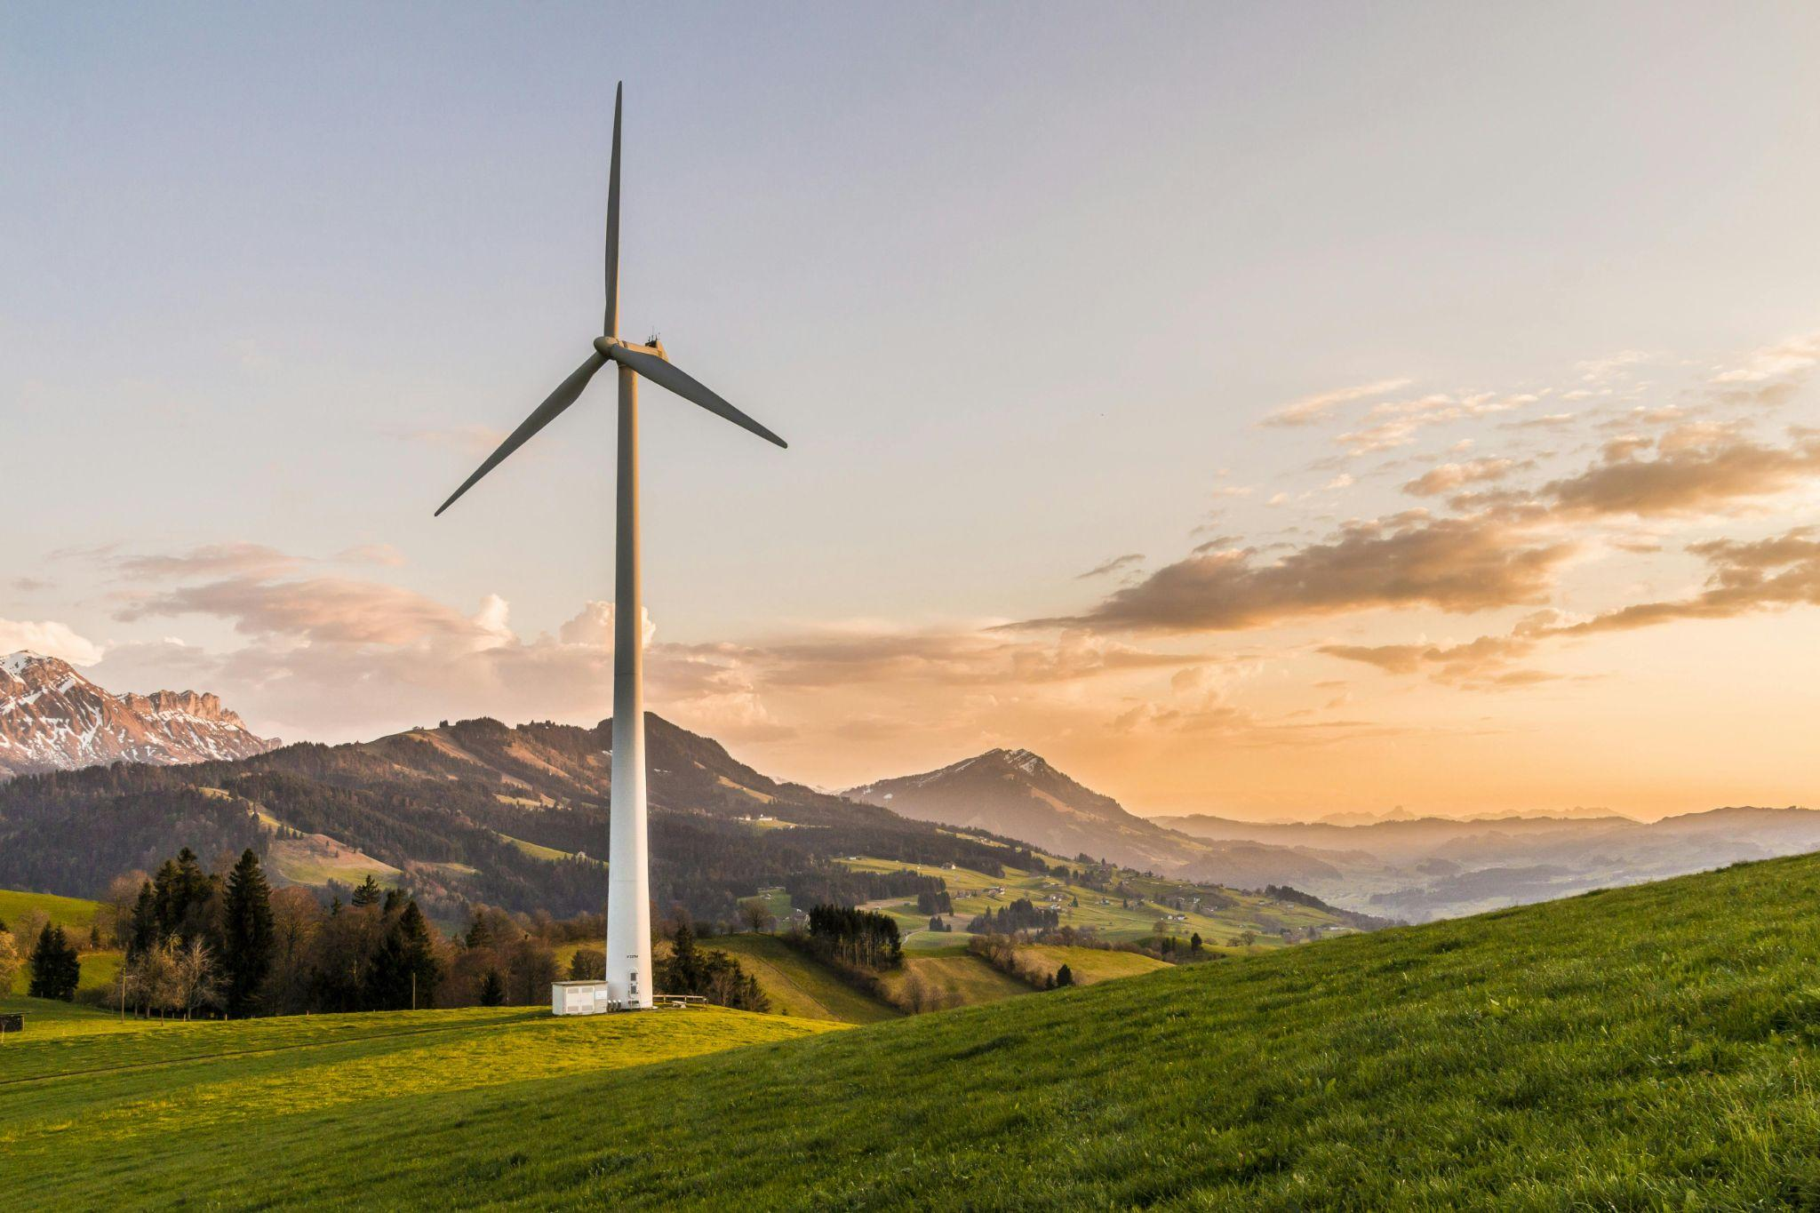

Photo by Pixabay: <https://www.pexels.com/photo/white-windmill-414837/>

white wind turbine in a remote area

Hydroelectric power is another sustainable technology that is able to help climate change and air pollution. By replacing fossil fuels, natural gas, and coal. Hydroelectric power or hydropower is made from moving water. Hydropower uses flowing water to move a turbine’s blades. Hydropower uses a turbine to activate the generator. Thus, activating the generator to make electricity.

Hydropower is beneficial because, in the event of chaos, it can provide much help. Hydropower is able to turn on power grids fast in even the most severe weather conditions. Often being able to have a power grid backup for an average of 7 hours in 2021 (U.S. Department of Energy, 2023).

It is without question a great resource to have for recent trends of droughts too. According to (the U.S. Department of Energy, 2023) the Pacific Northwest National Laboratory found even during the worst droughts between 2001 - 2021.

Hydropower was able to generate 80% (U.S. Department of Energy, 2023) of its normal capacity.

Electric vehicles are yet another help in climate change and air pollution. By not producing carbon dioxide from driving. There is also another area electric vehicles thrive in, that gasoline-dependent vehicles do not. That area is in noise pollution. Which when exceeding the threshold of 75 decibels can contribute to hearing loss. Gasoline vehicles are known to reach these limits very easily.

Why do gasoline vehicles have higher decibels (dB) than electric vehicles? The reasons are engine noise, and the speed of the vehicle (Noise Pollution Clearinghouse, 2025). If the speed reaches 33Mph of a medium-sized vehicle (Noise Pollution Clearinghouse, 2025). It can contribute to hearing loss. 33Mph reaches a dB level of 75, within a 50-foot radius of the vehicle according to (Noise Pollution Clearinghouse, 2025).

Electric vehicles have an electric engine that operates at lower dB than traditional vehicles. Electric vehicles will have much more impact on bigger cities. Due to the amount of traffic noise generated by more than one vehicle. Furthermore, it benefits human health, by preventing hearing loss.

Smart grids are another one to add to sustainable technology. A smart grid is a network that operates on real-time data analytics, sensors, and computer technology. The benefit of using smart grids is they can monitor how much electricity is produced (Smart, 2022). They can also see how much electricity is being used by customers.

Smart grids can use greener energy like solar panels and solar winds (Smart, 2022). A big theme throughout sustainable technology is less use of fossil fuels. This is because air pollution and climate change are being affected negatively. By the gas emissions of fossil fuels.

Smart grid helps to monitor energy usage closely. The traditional power grid only has one-way communication, while the smart grid has two-way communication. What does this mean? The power grid only produces energy from power plants to consumers (KPMG, 2020).

Smart grids allow consumers to demand an amount that does not contribute to blackouts later. While, at high production of energy usage, consumers can demand lower usage of energy (KPMG, 2020). So, fossil fuels do not have to be used at power plants.

Instead, they can still use solar power (KPMG, 2020) because of the minimization of energy usage during those peak times. They provide a way to save the waste of energy by watching the consumption and production of energy. Or the supply and demand of energy.

This is a better solution than previous power grids. That would produce too much energy resulting in the blackout to the power grid. Leaving many without power, because no monitoring was being used for energy usage.

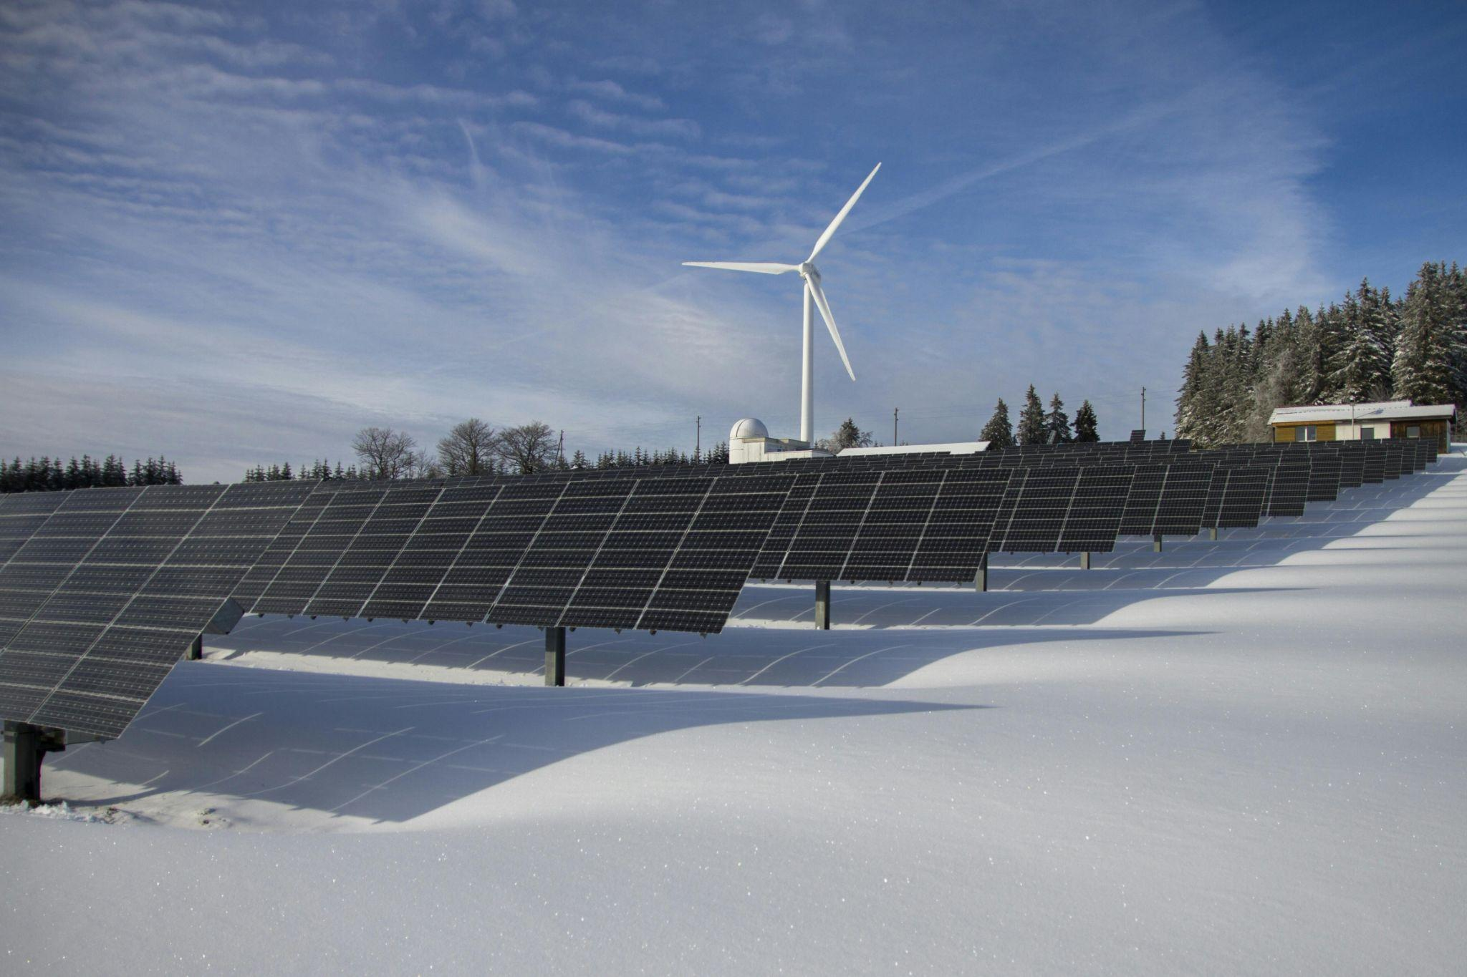

Photo by Pixabay: <https://www.pexels.com/photo/solar-panels-on-snow-with-windmill-under-clear-day-sky-433308/>

Solar panels on snow with wind turbine behind using sunlight for electricity

## **Career Opportunities in Sustainable Technology**

Sustainable technology will make advancements again and again to help the environment. Also, helps make technology more efficient and overall better. To do this, it is detrimental to understand the environmental impacts of technology. Also, to understand how the technology is currently impacting the environment and what can be done to get better outcomes.

* Data Scientists
* Research Scientists
* Data Engineer
* Environmental Scientists
* Environmental Geologist (Indeed, 2025)

## **Biotechnology in Agriculture**

Moving on from sustainable technology. We have biotechnology in agriculture. Another very important subject that matters for the future.

Biotechnology in agriculture can potentially change farming. This is due to the process of current farming. Introducing (USDA, 2024) pesticides, diseases, herbicides, and the environment has to be good enough, to not experience a drought. There are a lot of factors that influence the production of farming.

Biotechnology in agriculture has introduced fixes in protecting crops from insects that could contaminate the water and environment according to (USDA, 2024). Herbicides are chemicals that kill weeds but are toxic to humans. Biotechnology has led to less need for weed control (USDA, 2024). Helping make herbicides an unused product in agriculture. Providing food with no toxic chemicals (USDA, 2024) on them.

Another issue with traditional agriculture is tillage. Tillage is the process of plowing dirt to plant crops. This introduces issues with the soil, by causing erosion to the soil (USDA, 2024). Leading to less nutrients in your food. Making life harder for farmers, due to less support and water for their crops.

Biotechnology shines in all these areas. As they are engineered, to not be affected by certain herbicides. Also, certain pesticides have no effect on plants due to the engineering. Helping again to make life easier for farmers and their crops. Biotechnology uses soil but because of the resistance to herbicides. This reduces the need for tillage, helping make soil and crop health better.

Diseases are another area biotechnology in agriculture is taking us. Biotechnology is able to watch out for diseases caused by insects, bacteria, fungi, or viruses. As more and more advancements are being made in agriculture from biotechnology. The more humans and wildlife will reap the benefits.

From having healthier foods to eat, and finding new innovative ways to come up with groundbreaking engineering. Farmers will be able to save their investment in their crops because the herbicides and pesticides will already be handled. Providing more income, from less investment in safety for their crops.



Photo by Mikhail Nilov: <https://www.pexels.com/photo/micropropagation-method-of-hybrid-willows-8851084/>

Micropropagation method of hybrid willows

## **Career Opportunities in Biotechnology in Agriculture**

Biotechnology in agriculture has a ton of career opportunities. For advancements to be made in agriculture data will be a key aspect. Also, extensive research, for new ways to combat new diseases to make crops healthier.

* Research Scientist
* Molecular Biologist
* Microbiologist
* Biostatistician
* Bioinformatics Scientist (Reyell, 2024)

## **Autonomous Vehicles**

Autonomous vehicles are the last subject of tech industry trends today. These are self-driving cars that are able to stop at a red light. These vehicles can change lanes, merge into traffic, and not cause accidents while doing so.

How is this possible? By using machine learning, algorithms, software, sensors, and processors. Through radars, cameras, and Light Detection And Ranging (LiDAR). According to (Forbes, 2024) those are three pieces of technology that feed data to the algorithms, machine learning, etc. This helps the vehicle stop, start, and change lanes.

However, there are issues in certain weather conditions. Such as snow or rainy conditions, that don't allow the car to easily spot driving lanes or other cars. The technology for autonomous vehicles is not quite there yet. In perfect conditions, you can trust the vehicle to make decisions and drive well. In bad conditions though it would be safer and better for a human to drive, for now.

What are the advantages of autonomous vehicles? This could mean safer travel for people with disabilities. Helping them get to work on time, running errands, or long travel. Due to the higher efficiency in driving situations. Using these for public transportation could help with faster transportation. Autonomous vehicles do not have to stop for a bite to eat, so there would be no breaks in support of public transportation.

One of the biggest areas autonomous vehicles could help with is less traffic accidents. According to a report done by the National High Traffic Safety Administration (Forbes, 2024). They found self-driving technology would help drivers more easily, see dangers before they happen, and help avoid them.

Autonomous vehicles drive better and more efficiently than humans and would decrease intoxicated accidents. Autonomous vehicles would decrease the amount of traffic jams and decrease greenhouse emissions.

According to (Forbes, 2024) 9% reduction in greenhouse gas emissions. This is because the energy use of autonomous vehicles is more efficient than traditional driving. Also, saving people money because of the efficiency of driving. You would have fewer accidents, faster and more efficient travel time, and lower cost of insurance.

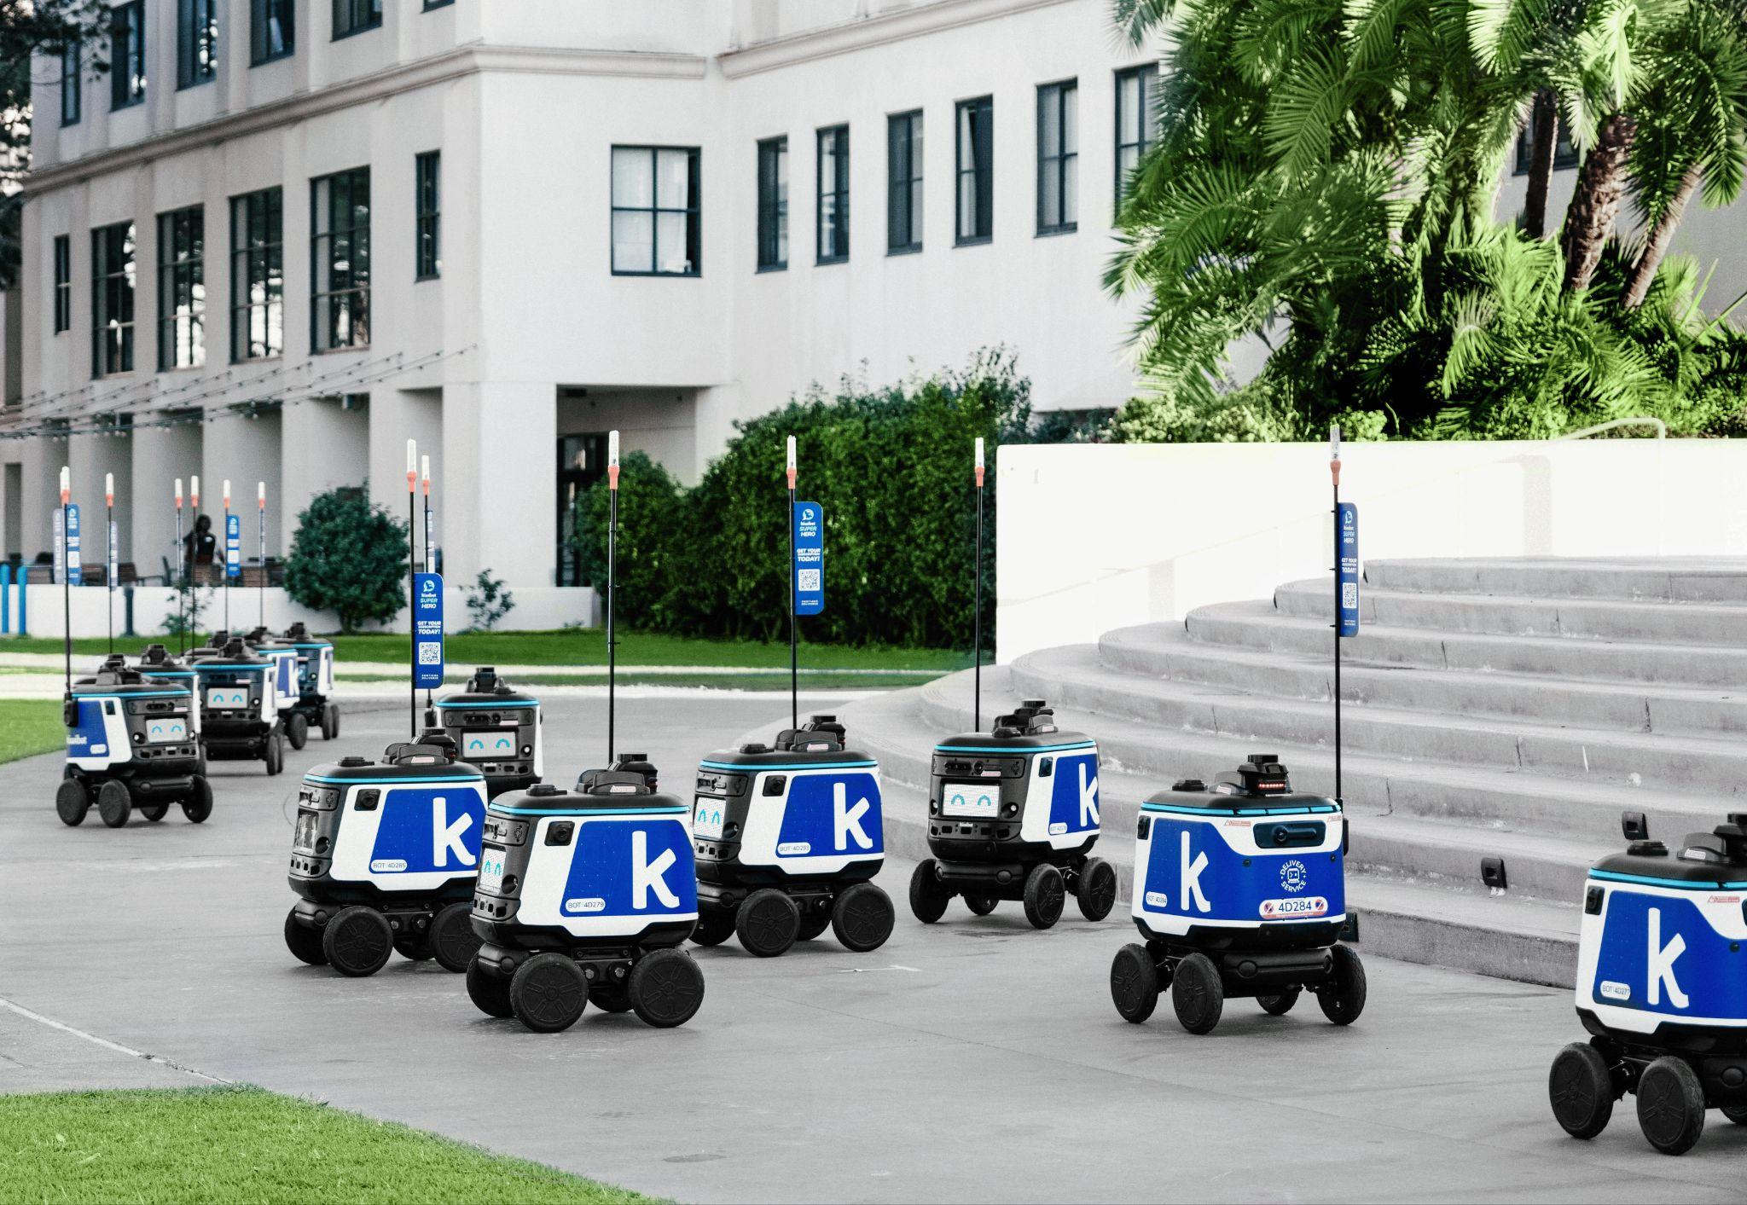

Photo by Catalina Carvajal Arango: <https://www.pexels.com/photo/robots-on-wheels-17332439/>

Robots on wheels near a building

## **Career Opportunities in Autonomous Vehicles**

The job opportunities for autonomous vehicles would be for what makes the car self-sufficient. The algorithms, machine learning, software development, processors, and sensors. The engineers will have their hands full with endless testing and learning curves.

* Machine Learning Engineer
* Data Scientists
* Natural Language Processor Engineer
* Machine Learning Research Assistant
* Data Engineer (GeeksforGeeks, 2019)

## **References**

1. <https://www.oracle.com/artificial-intelligence/generative-ai/what-is-generative-ai/>
2. <https://www.delveinsight.com/blog/generative-ai-drug-discovery-market-impact>
3. <https://www.sentinelone.com/cybersecurity-101/data-and-ai/generative-ai-cybersecurity/>
4. Fortinet. (2025). *Quantum Security: Preparing for the Next-Generation of Cyber Threats | Fortinet*. Fortinet.<https://www.fortinet.com/resources/cyberglossary/quantum-security>
5. <https://cybervie.com/blog/role-of-quantum-computing-in-cybersecurity/>
6. SpinQ. (2025). *6 Top Quantum Computer Applications with Real-World Examples*. Spinquanta.com.<https://www.spinquanta.com/news-detail/top-quantum-computer-applications-with-real-world-examples20250113034956>
7. <https://www.ibm.com/think/topics/quantum-computing>
8. <https://patentpc.com/blog/quantum-computings-impact-on-ai-training-speeds-and-model-efficiency-stats>
9. Goss, M. (2023, October 26). Learn the key differences between 4G vs. 5G networks. SearchNetworking.<https://www.techtarget.com/searchnetworking/feature/A-deep-dive-into-the-differences-between-4G-and-5G-networks>
10. <https://nordvpn.com/blog/benefits-of-iot/>
11. <https://www.ibm.com/think/topics/edge-computing>
12. <https://www.fortinet.com/resources/cyberglossary/artificial-intelligence-in-cybersecurity>
13. Level Blue. (2024, January 22). *Deep Dive into Blockchain Security: Vulnerabilities and…*. Levelblue.com.<https://levelblue.com/blogs/security-essentials/deep-dive-into-blockchain-security-vulnerabilities-and-protective-measures>
14. <https://www.ibm.com/think/topics/blockchain>
15. Beyond. (2024, March 15). *Exploring the Profound Benefits of LED Lights: Insights from Beyond LED Technology Specialists*. Beyond LED Technology.<https://beyondledtechnology.com/blogs/articles/exploring-the-profound-benefits-of-led-lights-insights-from-beyond-led-technology-specialists>
16. Hedgehog. (2022, January 10). Advantages of LED Lights Compared to Traditional Lighting. HedgeHog Electric.<https://hedgehogelectric.com/advantages-of-led-lights-compared-to-traditional-lighting/>
17. Richardson, J. (2019, March 12). *Why are Solar Panels Good for the Environment?* The Renewable Energy Hub; Renewable Energy Hub.<https://www.renewableenergyhub.co.uk/main/solar-panels/why-are-solar-panels-good-for-the-environment>
18. U.S. Department of Energy. (2022). *Advantages and Challenges of Wind Energy*. Energy.gov; Office of Energy Efficiency & Renewable Energy.<https://www.energy.gov/eere/wind/advantages-and-challenges-wind-energy>
19. U.S. Department of Energy. (2023, August 24). *Hydropower Is Key to a Clean Energy Future—Here’s Why*. Energy.gov.<https://www.energy.gov/eere/water/articles/hydropower-key-clean-energy-future-heres-why>
20. <https://www.nrel.gov/news/video/hydropower-energy-basics-text#:~:text=Using%20the%20power%20of%20the,Hydropower%20is%20continually%20evolving>.
21. Noise Pollution Clearinghouse. (2025). *NPC Resources: Noise Increases with Vehicle Speed*. Nonoise.org.<https://nonoise.org/resource/trans/highway/spnoise.htm>
22. Smart. (2022, September 29). *Smart Grids: Everything You Need to Know*. Greenly. Earth.<https://greenly.earth/en-us/blog/industries/smart-grid-all-you-need-to-know>
23. KPMG. (2020). *Smart grids: A forgotten key to decarbonization*. KPMG.<https://kpmg.com/xx/en/what-we-do/industries/energy-natural-resources-chemicals/power-utilities/plugged-in-magazine-3/smart-grids-a-forgotten-key-to-decarbonization.html>
24. USDA. (2024, December 11). *Biotechnology FAQs*. Usda.gov; U.S. Department of Agriculture.<https://www.usda.gov/farming-and-ranching/plants-and-crops/biotechnology/biotechnology-faqs>
25. Forbes. (2024, January 23). *What Are Self-Driving Cars? The Technology Explained*. Forbes; Forbes.<https://www.forbes.com/sites/technology/article/self-driving-cars/>
26. GeeksforGeeks. (2019, June 13). *Top Career Paths in Machine Learning - GeeksforGeeks*. GeeksforGeeks.<https://www.geeksforgeeks.org/top-career-paths-in-machine-learning/>
27. Reyell, B. (2024, July 9). *7 Popular Bioinformatics Careers*. Northeastern University Graduate Programs.<https://graduate.northeastern.edu/knowledge-hub/top-bioinformatics-careers/>
28. Indeed. (2024). *9 Jobs in the IoT Industry (With Salaries and Duties)*. Indeed Career Guide.<https://www.indeed.com/career-advice/finding-a-job/jobs-in-iot-industry>
29. Tonex. (2020, January 3). *RF Engineering Training Bootcamp Course*. Tonex Training.<https://www.tonex.com/rf-engineering-training-bootcamp-course/>
30. DADB. (2024, October 21). *Career After Engineering: Career Paths in IoT, 5G & eMobility*. DADB India. <https://dadb.com/in/blog/career-options-after-engineering-5g-technology-iot-emobility/>
31. <https://www.ibm.com/think/topics/5g-types>